Creating Office 365 PowerApps Trial Environments

If you would prefer not to use your current work account for the labs, you can follow the instructions

1. Sign Up For Office 365 E3 Trial account at the following link - [Office 365 E3 Trial](https://signup.microsoft.com/Signup?OfferId=B07A1127-DE83-4a6d-9F85-2C104BDAE8B4&dl=ENTERPRISEPACK&ali=1)

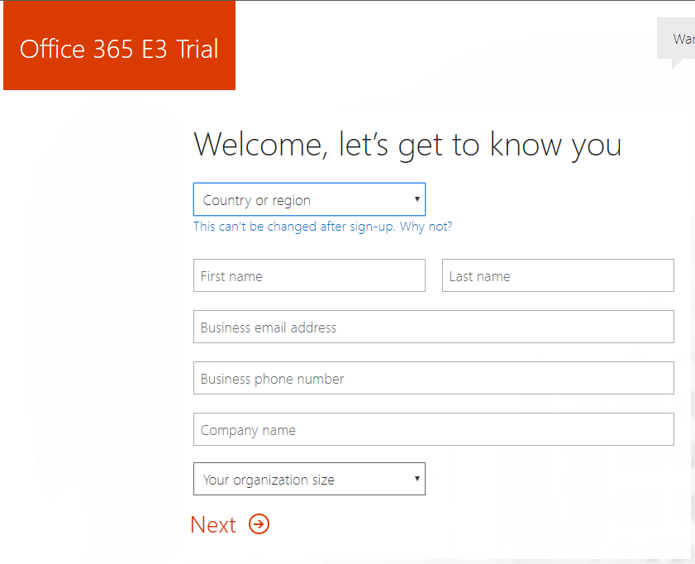

We recommend you not use your work Office 365 email address to avoid confusion. For example, I used an Outlook.com email address. This email will be used to send you the new account details.

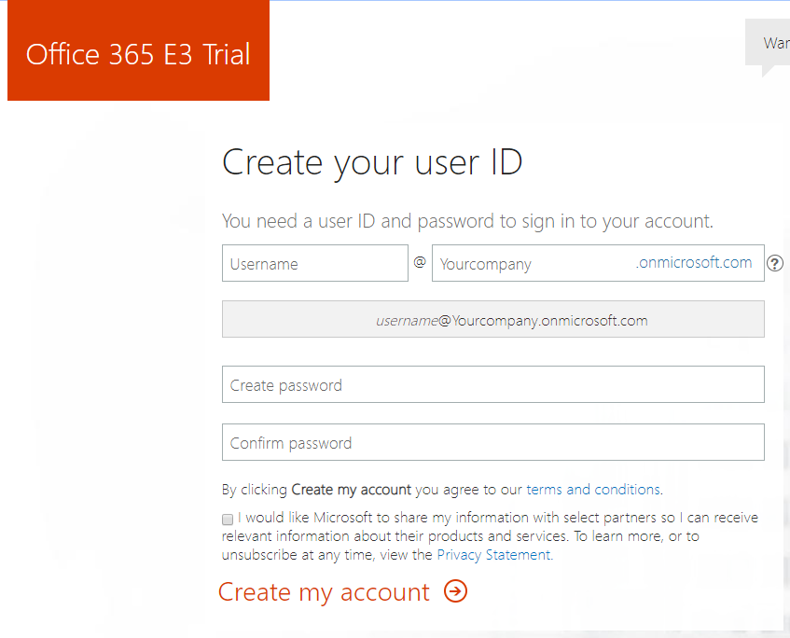

Choose a unique name for your account. For a real instance, this would be your company name. For our labs, you might choose something like **admin** and **aiadrestontest**:

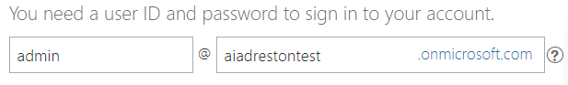

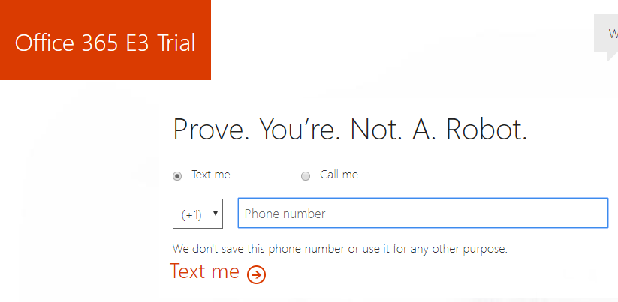

You will receive a validation code to… **Prove. You’re. Not. A. Robot.**

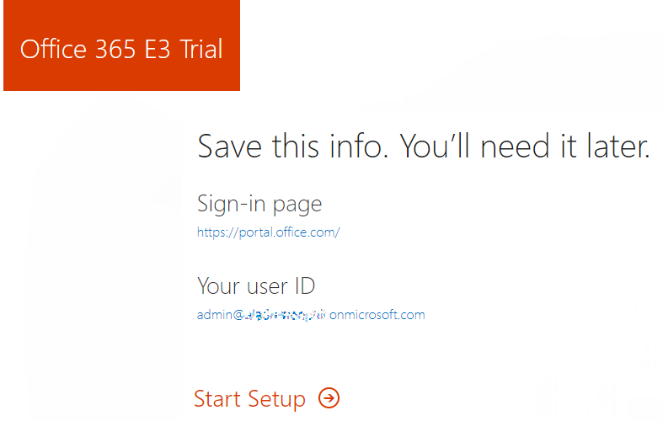

Once you complete this step, you should receive an email with your account info.

1. Login to your new Office Trial account and use the following link set up the PowerApps trial -

[PowerApps Plan 2 Trial Offer](https://portal.office.com/Commerce/Trial.aspx?OfferId=767AD45E-9508-479C-8109-2022F6EA4362)

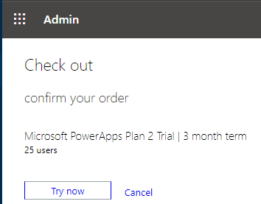

Here you just need to choose Try now!

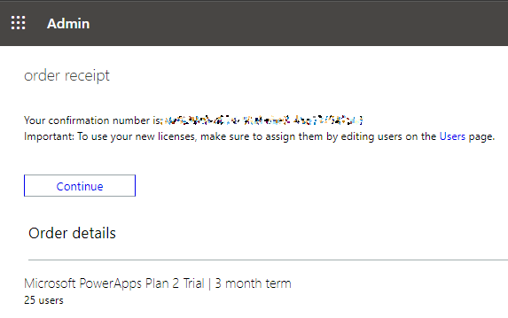

From here, click the link to the Users page. It may take a moment or two to load.

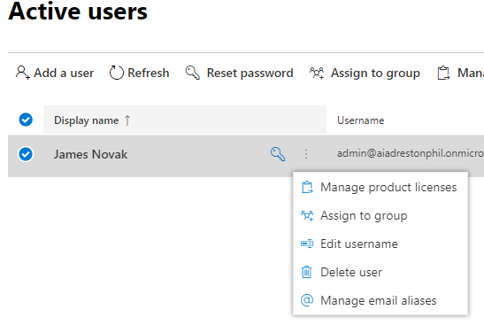

Select the menu next to the key icon by clicking the vertical ellipses and choose Manage Product Licenses.

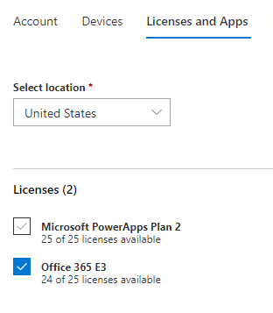

In the Account details pane to the right, select Licenses and Apps. Check the Microsoft PowerApps Plan 2 item and choose Save.

You should now be able login to the Power Apps portal at <https://make.powerapps.com/home>

NOTE – Before running any automated PowerShell scripts against this new tenant, you must login at least once to the <https://make.powerapps.com> site.